Maharashtra State Board of Technical Education, Mumbai



AN
INTERNSHIP REPORT
ON

“College Sahayak”

Submitted By

Date Yash Vijay

Under The Guidance Of

Mrs. S. B. Chavan



DEPARTMENT OF COMPUTER ENGINEERING
GOVERNMENT POLYTECHNIC, AWASARI KH.
TAL-AMBEGAON, DIST-PUNE 412405
(2026 – 2027)

Maharashtra State
Board of Technical Education

Certificate of Completion
Of Industrial Training
(By respective Head of the Department & Head of the Institute)
This is to certify that Mr. Yash Vijay Date with Enrollment No. 24210270230 has successfully completed Industrial Training (315004) in “Somayu Infotech” From 25-05-2026 to 14-08-2026 For Partial fulfillment towards completion of Diploma in Computer Engineering from Government Polytechnic Awasari (Khurd) Institute Code 1051

Signature | Seal of the Institute | Signature
Head of the Department |  | Head of the Institute

ABSTRACT
I have attended 12-week Industrial Training Program which was designed to bridge the
gap between academic learning and industry requirements. The training emphasized
hands-on experience with trending technologies and tools that are currently reshaping the
IT landscape.
I was exposed to a blend of theoretical concepts and practical sessions in high-demand
areas such as Web Development (HTML, CSS, JavaScript, React.js), Backend
Technologies (Node.js, Python), Database Management (MySQL/XAMPP), Data
Analytics (Power BI), and the Basic Artificial Intelligence.
The program included real-time project development, industry-oriented assignments, and
collaborative teamwork to simulate a real workplace environment. It aimed to enhance
technical skills, problem-solving abilities, and overall employability by fostering a deeper
understanding of software development life cycles, agile methodologies, version control
systems like Git, and professional communication.
By the end of the training, I had not only gained industry-relevant technical knowledge
but also developed the confidence to face real-world IT challenges, making them job-ready
and capable of contributing effectively in their future roles.

ACKNOWLEDGEMENT

I wish to express my sincere gratitude to Mr. Yuvraj Hande, Founder of the Company for providing me an opportunity to do my 12 weeks Industrial Training in “Somayu Infotech”
I sincerely thank Mr. Yuvraj Hande, Industrial Supervisor for his guidance and encouragement in carrying out this Industrial Training. I also wish to express my gratitude to the officials and other staff members of “Somayu Infotech” who rendered their help during the period of my Industrial Training.
I am also thankful to Dr. Vitthal Bandal Sir, Principal of Government Polytechnic Awasari (Khurd) for providing me the opportunity to embark for Industrial Training.
And I also thanks to Mrs. M. G. Yawalkar, Head of Department Computer Engineering, Mrs. S. B. Chavan, Mentor and all supporting staff from Institute.

CONTENTS

 | Title | Page No.
Abstract |  | I
Acknowledgement |  | II
Contents |  | III
- Organization Structure of Industry and General Layout 1-3
- Introduction of Industry 4-6
- Details of Equipment and Tools 7-10
- Engineering / Development Process 11-13
- Testing Tools and Methods 14-15
- Safety Procedures Followed and Safety Gears Used by Industry 16-18
- Particulars of Practical Experiences in Industry 19-20
- Detailed Report on Task Undertaken 21-32
- Special / Challenging Experiences 33
- Conclusion 34
- References 35-36

CHAPTER 1
ORGANIZATION STRUCTURE OF INDUSTRY AND GENERAL LAYOUT

ORGANIZATION STRUCTURE OF INDUSTRY
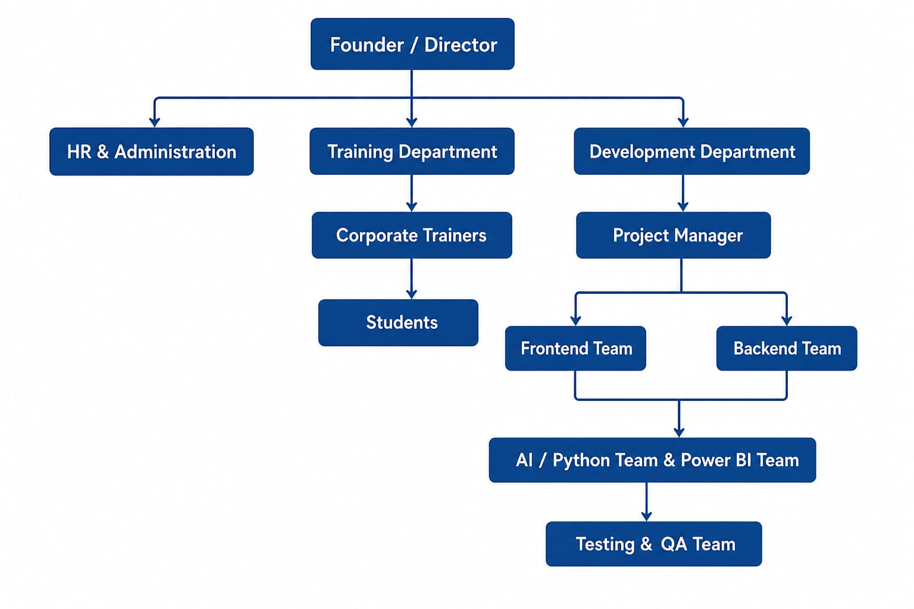

INFORMATION
Somayu Infotech is a leading technology and software solutions company based in Narayangaon, Pune. Established with a vision to deliver innovative and customized IT services. Somayu Infotech specializes in software development, IT consulting, and digital transformation.

Committed to excellence and customer satisfaction, the company leverages cutting-edge technology to empower businesses and enhance their operational efficiency.
The company’s customer-centric approach and emphasis on continuous innovation have made it a trusted partner for startups, SMEs, and large enterprises alike.

Marketing Department: This department is used for the promotion and advertising of the software. This department promotes the software in the market and gives a basic information and the working of the software to the client. The peoples in the group has the knowledge of the working of the software and don’t involve in the development software.

Sales Department: This department involves giving the demo of the software to the client also it handles the dealing of the software with the customer. The Sales Department gives the details of the clients to the Accounts Department.

Account Department: The Account Department takes the details of the client and then receives the payment from the customer.
IT Team: This team is the software developing team, this team develops the software according to the client requirements. Also, this team provides the actual training of the software to the client side for their help.
Support Department: This department is raised for the clients help. If they found any query or error in the software or also if any requirement is missing then they can contact to support department. Here, their case is registered and actions are taken immediately on that particular issue.
H/W and N/W Department: This department is raised for providing support for the devices or machines used in the company.

CHAPTER 2

INTRODUCTION OF INDUSTRY

COMPANY ORGANIZATION:

At Somayu Infotech Pvt. Ltd., we believe in solving real world problems through simple and effective IT solutions.
We have a rich experience of 12 years in Software Product Development. We prefer Quality of solution over Quantity.
Somayu Infotech is an IT Training and Software Development company specializing in industrial training, enterprise software development, AI solutions, Python applications, Power BI dashboards, and web technologies.

TYPE OF PRODUCT DEVELOPED:

- ERP Systems
- CRM Applications
- Student Management System
- AI Chatbots
- Python APIs
- Full-Stack Web Applications
- Power BI Dashboards
- E-Commerce Websites
- Attendance Systems
- Inventory Management System

HISTORY:

Somayu Infotech commenced its operations on 2nd June 2012 with the vision of providing high quality software development services and industry-oriented IT training. Since its establishment, the organization has been committed to bridging the gap between academic learning and industry requirements through practical, project-based training and real-world software development experience. Over the years, Somayu Infotech has expanded its expertise in Full-Stack Web Development, Artificial Intelligence (AI), Python Programming, REST API Development, Data Analytics, Microsoft Power BI, Cloud Computing, and Software Engineering. The company has successfully trained numerous students and professionals while delivering innovative software solutions to clients across various industries. Today, Somayu Infotech is recognized as a trusted IT training and software development organization that focuses on technical excellence, innovation, and continuous learning, preparing students and professionals for successful careers in the Information Technology industry

Turn over:

Somayu Infotech generates revenue through software development services, industrial training, corporate training, IT consulting, and technology solutions. Based on the scale of operations and workforce, the company's estimated annual turnover ranges between ₹25 Lakh and ₹50 Lakh. The organization has approximately 25 employees and operates as a small to medium IT services and training organization.
Revenue Sources: The major revenue sources of Somayu Infotech include Software Development, Industrial Training, Corporate Training, and IT Consulting.
Estimated Annual Turnover: The estimated annual turnover of the company is approximately ₹25 Lakh – ₹50 Lakh.
Business Category: Somayu Infotech is categorized as a Small to Medium IT Services & Training Organization.

Number of Employees:
Approximately 15–30 professionals including:
- Developers
- Trainers
- Project Managers
- HR Executives
- Quality Analysts
- Support Staff
CHAPTER 3
DETAILS OF EQUIPMENT AND TOOLS.

Hardware used
Server with specification:
- Specification: Multiple cores, high RAM capacity, large storage (SSD or HDD), redundancy for critical components.
- Approximate Cost: Can vary significantly based on
- specification and usage.
- Specific Use: Hosting web applications, databases, version control systems, and other development-related services.

Desktops and laptops with specification:

- Specification: High-performance processors (e.g.,IntelCorei7ori9)
- RAM (16 GB or more),
- Storage: Fast SSD Storage (512 GB)
- Specific Use: Primary tools for software development, coding, testing, and debugging.
- OS: Windows11/Ubuntu Linux
- Monitor: 22-24 inch LED
- Maintenance Schedule: Regular software updates, periodic cleaning to prevent dust build-up, and backups to safeguard data.

Networking equipment:
- Specification: Routers, switches, and firewall with gigabit Ethernet or higher speeds.
- Specific Use: Connecting computers, servers, and other devices with in the development environment and ensuring reliable data transfer.

Software used
Software with specification:
- Visual Studio Code: Used as the main code editor for developing and managing the project files.
- Node.js: Used as the backend runtime environment for executing server-side JavaScript.
- React.js: Used for developing the frontend and creating the user interface of the application.
- Express.js: Used for developing REST APIs and handling backend requests and responses.
- MySQL: Used as the database for storing and managing application data.
- Git: Used for version control and tracking changes in the project.
- GitHub: Used for storing and managing the project repository.
- Postman: Used for testing and verifying REST APIs.
- Power BI Desktop: Used for creating dashboards and visualizing data.
- XAMPP: Used as a local server environment where required

Software cost:
Since all the required tools are used, most of them are free or open-source, so there is no additional software licensing cost.
The company uses tools such as VS Code, Node.js, React.js, MySQL, Git, Postman, Power BI Desktop and Ubuntu Linux.
Hence, the overall software cost is minimal or free.

Maintenance Procedures:

- Daily Data Backup:
Regular backups of important data are taken daily to prevent data loss and ensure data recovery when required.
- Antivirus Updates:
Antivirus software is regularly updated to protect the system from viruses, malware, and other security threats.
- Windows Updates:
Windows operating system updates are installed regularly to improve system security, performance, and stability.
- Database Optimization:
The database is regularly checked and optimized to improve data storage, retrieval speed, and overall system performance.
- Server Monitoring:
The server is monitored regularly to ensure that applications and services are running properly without interruptions.
- Hardware Maintenance:
Computer hardware and other devices are checked and maintained regularly to ensure proper functioning.
- Network Security Monitoring:
The network is monitored to identify security issues and protect the system and data from unauthorized access.

CHAPTER 4
ENGINEERING / DEVELOPMENT PROCESS

Types of all development models
- Waterfall Model:
A linear and sequential development process. Each phase (Requirements → Design → Development → Testing → Deployment) is completed before moving to the next.
- Agile Model:
An iterative and incremental approach.Development is done in short cycles (sprints) with regular client feedback and continuous improvements.
- V-Model (Validation and Verification Model):
An extension of the Waterfall model where testing is planned in parallel with development phases.
- Spiral Model:
Focuses on risk analysis and iterative development through repeated cycles (spirals).
- Iterative Model:
Starts with a simple version of the software, and features are gradually added in iterations.
- RAD (Rapid Application Development):
Emphasizes rapid prototyping and quick feedback over long development cycles.

Development Process used by Company
Somayu Infotech primarily follows the Agile Software Development Model.
Agile Process
- Requirement Gathering
- Planning
- UI/UX Design
- Development
- Testing
- Client Review
- Deployment
- Maintenance

Phases of the Waterfall Model

- Requirement Analysis – Collect and document all system requirements.
- System Design – Prepare system architecture, database design, and interface layout.
- Implementation (Coding) – Write code according to the design specifications.
- Integration & Testing – Combine modules and test the system for errors.
- Deployment – Deliver the final software to the client or production environment.
- Maintenance – Fix issues, provide updates, and ensure smooth operation post-deployment.
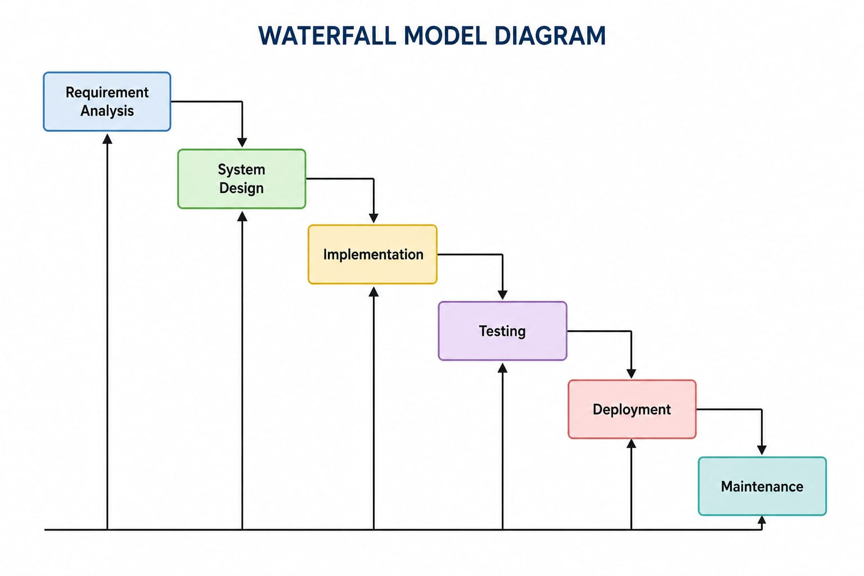

CHAPTER 5
TESTING TOOLS AND METHODS

Testing Tools:

- Postman: Used to test APIs by sending different requests and checking responses, status codes, and error handling.
- Browser Developer Tools: Used to identify frontend errors, inspect webpage elements, and debug HTML, CSS, and JavaScript.
- Chrome DevTools: Used to check website performance, network requests, console errors, and page loading issues.
- GitHub: Used for managing source code, tracking changes, and reviewing different versions of the project.
- Power BI Validation: Used to verify dashboard data, charts, reports, and ensure that the displayed information is accurate.

Testing Methods:

- Unit Testing: Individual modules and functions are tested separately to ensure that each component works correctly and produces the expected output.
- Integration Testing: Different modules such as frontend, backend, database, and APIs are tested together to verify that they communicate and work properly.
- System Testing: The complete system is tested as a whole to check whether all features and functionalities work according to the requirements.
- Functional Testing: Each function and feature is tested to ensure that it performs the expected operation correctly under different conditions.
- Regression Testing: Previously working features are tested again after making changes or adding new functionality to ensure that existing features are not affected.
- Performance Testing: The system is tested for response time, loading speed, stability, and performance when handling different levels of usage.
- User Acceptance Testing (UAT): The system is checked from the user's perspective to confirm that it satisfies the required business and user requirements.
- API Testing: APIs are tested using tools such as Postman to verify requests, responses, status codes, data validation, and error handling.
- Security Testing: The system is checked for basic security issues such as unauthorized access, incorrect login attempts, and protection of user data.
CHAPTER 6
SAFETY PROCEDURES FOLLOWED AND SAFETY GEARS USED BY INDUSTRY

Safety procedures followed by industry:

- Electrical and Hardware Safety
  - Ensure all computers, servers, and networking equipment are
properly grounded.
  - Avoid overloading power strips or extension cords.
  - UPS (Uninterruptible Power Supply) and surge protectors are installed to prevent data loss and equipment damage.
  - Loose cables are secured to avoid tripping hazards.

Ergonomics and workspace safety
  - Ergonomic chairs, desks, and monitor stands provided to prevent RSI
(Repetitive Strain Injury) and back pain.
  - Regular audits of workstations to comply with occupational health guidelines.

Mental health and stress management
  - Mental wellness programs and counselling services are made available.
  - Regular breaks and optional flexible working hours to reduce burnout.
  - Team-building activities and employee engagement to boost morale.

Cybersecurity and data protection
  - Strong password policies, 2FA (Two-Factor Authentication), and VPN usage are mandatory.
  - Regular updates of antivirus and firewall software.
  - Employees trained on phishing awareness and safe browsing practices.
  - Secure coding practices are followed during software development.

Fire and emergency preparedness
  - Fire extinguishers, smoke detectors, and emergency lights installed in offices.
  - Emergency evacuation drills are conducted at regular intervals.
  - Exit routes are clearly marked and kept accessible.

First aid and medical safety
  - First aid kits are available in office areas.
  - Staff trained in basic first aid and emergency response.
  - Tie-ups with nearby hospitals or clinics for quick medical support.

Cleanliness and hygiene
  - Regular sanitization of desks, keyboards, and common areas.
  - Air conditioning and ventilation systems maintained periodically.
  - Hand sanitizers, tissues, and clean restrooms available at all times.

Policy awareness and training
  - New employees undergo onboarding safety training.
  - Regular cybersecurity workshops and refreshers for all staff.
  - Display of safety instructions and contact details of safety officers.

Work-from-home safety (if applicable)
  - Guidelines for creating an ergonomic and secure home workstation.
  - Usage of company-approved devices and networks.
  - Awareness about home electrical and digital safety.

CHAPTER 7
PARTICULARS OF PRACTICAL EXPERIENCES IN INDUSTRY
- HTML/CSS WEBSITE DEVELOPMENT
I learned to create structured and responsive web pages using HTML and CSS. I worked on webpage layouts, forms, navigation bars, styling, and responsive designs.
- JAVASCRIPT PROGRAMMING
I learned JavaScript for adding dynamic functionality to web applications. I worked with functions, events, DOM manipulation, validations, and interactive features.
- REACT.JS COMPONENTS
I gained practical knowledge of React.js and component-based development. I learned to create reusable components, manage application data, handle events, and build interactive user interfaces.
- NODE.JS REST APIS
I worked with Node.js to develop backend REST APIs. I learned to handle HTTP requests, create API endpoints, perform CRUD operations, and connect the backend with the frontend.
- PYTHON API DEVELOPMENT
I gained basic practical experience in developing APIs using Python. I learned how backend services communicate with applications and how API requests and responses are handled.
- MYSQL DATABASE
I worked with MySQL for storing and managing application data. I learned database creation, table design, SQL queries, inserting, updating, deleting, and retrieving records.
- AI API INTEGRATION
I learned how AI APIs can be integrated into applications. I understood the process of sending requests to AI services and using the generated responses in applications.

- POWER BI DASHBOARD DEVELOPMENT
I gained experience in creating interactive dashboards using Power BI. I worked with data, charts, graphs, reports, filters, and visualizations to represent information effectively.
- GIT & GITHUB
I learned to use Git and GitHub for version control and project management. I practiced creating repositories, committing changes, pushing code, and maintaining project versions.
- CLOUD DEPLOYMENT
I gained practical knowledge of deploying web applications and APIs on cloud platforms. I learned about deployment processes, hosting, configuration, and making applications accessible online.
- REAL-TIME INDUSTRIAL PROJECTS
I worked on real-time projects that helped me apply my technical knowledge practically. These projects improved my coding, debugging, problem-solving, teamwork, and project development skills.

CHAPTER 8
DETAILED REPORT ON TASK UNDERTAKEN
INTRODUCTION
The main objective of the project was to develop College Sahayak, a comprehensive, full-stack educational web application designed specifically for MSBTE polytechnic diploma students in Maharashtra. The system acts as a centralized digital platform, allowing students to access verified academic resources such as K-Scheme curriculum details, lab manuals, manual answers, previous year question papers (PYQs), microprojects, and lecture notes.
A standout feature of the platform is College Mitra, an integrated AI-powered academic counselor that provides real-time, streaming responses to student queries, including code generation and MSBTE-specific exam guidance. The application uses a React.js (Vite) frontend for a lightning-fast user experience, a Node.js and Express.js backend for robust API handling, and Supabase (PostgreSQL) for secure database management and feedback collection. The project provided deep hands-on experience in the complete software development lifecycle, including modern frontend architecture, RESTful API design, AI/LLM integration (Groq API), SEO optimization, deployment, and version control

TECHNOLOGIES USED (IN DETAIL)
Frontend Technologies:
- React.js (vite)
React.js was used as the core library to develop the highly interactive frontend of College Sahayak. Vite was utilized as the build tool to ensure lightning-fast compilation and optimized production builds. Components were created for Home, Curriculum, Lab Manuals, Microprojects, Notes, Question Papers, and the AI Chatbot interface.
- React Router DOM
React Router DOM was implemented for seamless client-side routing, enabling smooth navigation between different resource pages without reloading the web browser.
- React Helmet Async
Used extensively for Technical SEO (Search Engine Optimization). It allowed dynamic injection of metadata, titles, and K-Scheme specific keywords into the <head> of every page to ensure high rankings on Google Search.

- HTML5 and CSS3
HTML5 provided the semantic structural foundation of the platform. CSS3 was heavily utilized to design a premium, modern aesthetic—incorporating dynamic hover effects, glassmorphism, responsive grid layouts, and smooth micro-animations that adapt flawlessly to both mobile and desktop screens.
- JavaScript
JavaScript was used to add dynamic functionality to the application. It was used for handling events, form validation, data processing, and interaction between frontend components and backend APIs.
Backend Technologies:
- Node.js
Node.js served as the server-side runtime environment. It efficiently handled asynchronous operations, API requests, AI stream processing, and secure communication with the database.
- Express.js
Express.js was used to develop REST APIs and manage the different routes of the application. Express.js was used to build the RESTful backend architecture. It managed routing for various endpoints, including fetching dynamic study materials, submitting user feedback, and handling the complex Server-Sent Events (SSE) required for the AI chatbot.
- Supabase (PostgreSQL)
Supabase was utilized as the primary database management system. It securely stores dynamic platform data, such as the admin feedback inbox, using relational table.

- REST API & Server-Sent Events (SSE)
Standard REST APIs handled data fetching and form submissions, while SSE was specifically implemented to stream the AI chatbot's responses word-by-word in real-time, drastically improving the user experience.

- Groq API (LLM Integration)
Groq's lightning-fast inference engine was integrated to power the College Mitra AI chatbot. Standard LLMs (like gpt-oss-20b/Llama 3) were securely connected via the backend to provide students with real-time, streaming academic assistance and programming code generation.

DEVELOPMENT TOOLS:
- Visual Studio Code
Visual Studio Code was used as the main code editor for writing, editing, and managing the frontend and backend source code of College Sahayak.
- XAMPP
XAMPP was used to run the local MySQL server and Apache environment during development and testing of the application.
- Postman
Postman was used for testing REST APIs. Different HTTP methods such as GET, POST, PUT, and DELETE were tested using Postman before integrating them with the frontend.
- Git
Git was used for version control and maintaining different versions of the project source code throughout the development of College Sahayak.

- GitHub
GitHub was used to store and manage the College Sahayak project repository for the course. It also helped in maintaining source-code history, tracking changes, and keeping a backup of the project.
(GitHub repository - https://github.com/YashDate31/College-Sahayak )
- Web Browser
A web browser was used to run and test the React application and verify the functionality and user interface of College Sahayak.

IMPLEMENTATION
College Sahayak was implemented using React.js (Vite) for frontend development, Node.js and Express.js for backend development, and Supabase for database management. The system includes a fully responsive multi-page layout containing resources such as Curriculum, Lab Manuals, Notes, and Microprojects. A standout implementation is the floating AI Chatbot (College Mitra), which utilizes Server-Sent Events (SSE) to stream responses from the Groq API in real-time. REST APIs were developed to connect the frontend with the backend, handling dynamic material fetching and feedback submissions. The application was thoroughly tested using Postman and web browsers, and the source code was maintained and version-controlled using Git and GitHub for the final deployment.

Output:
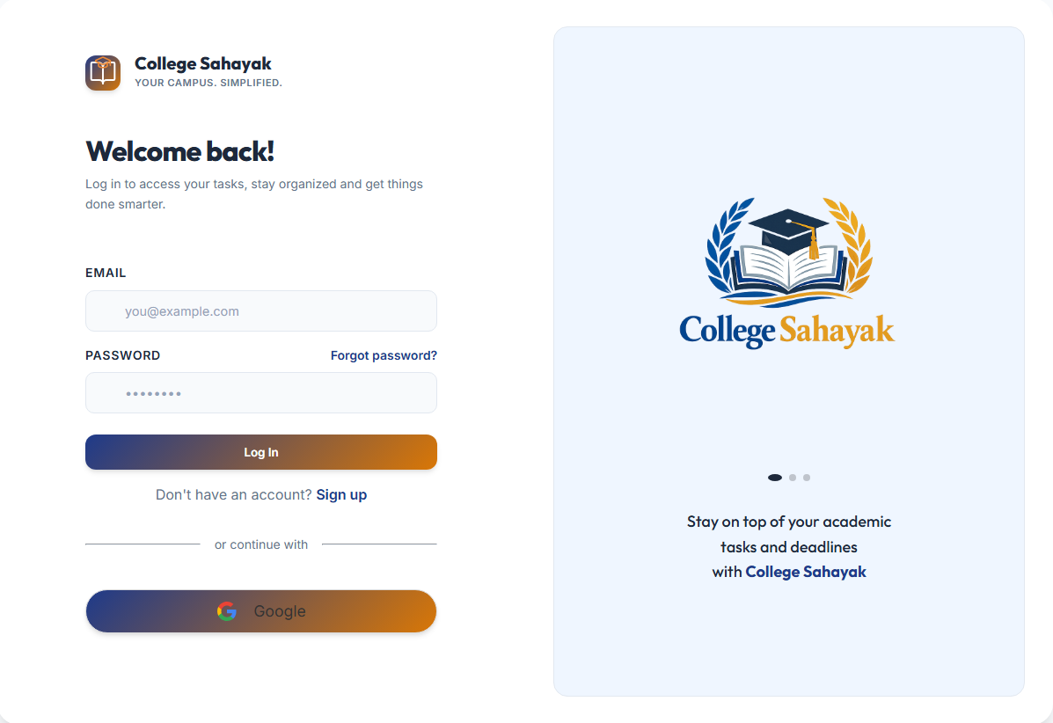
Fig 8.1 Login Page
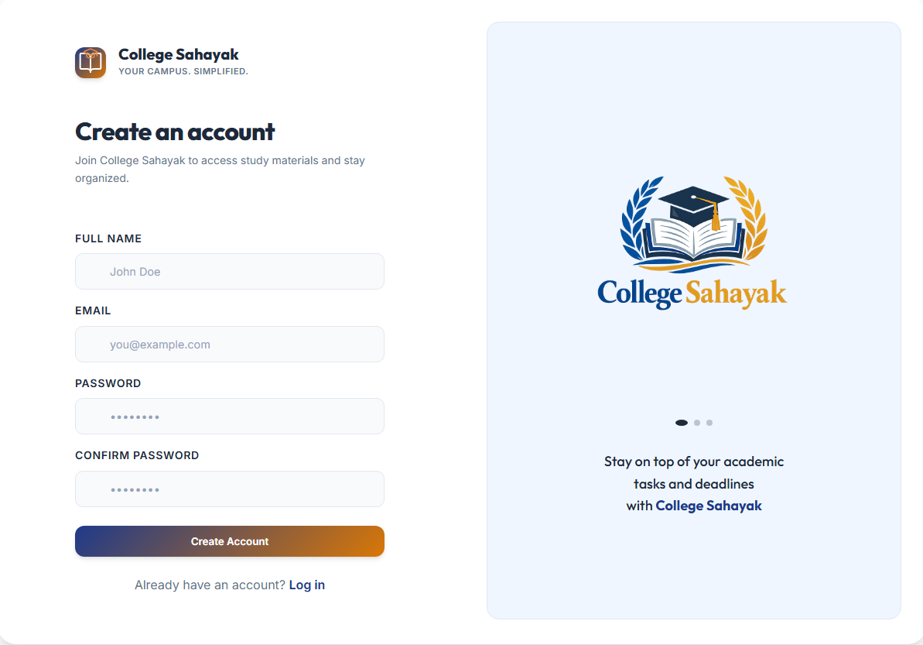
Fig 8.2 Register

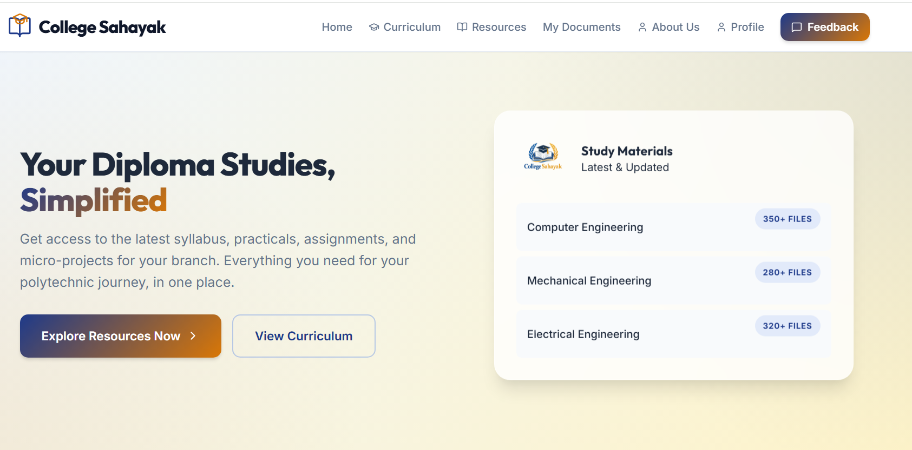
Fig 8.3 Home page (Landing Page)
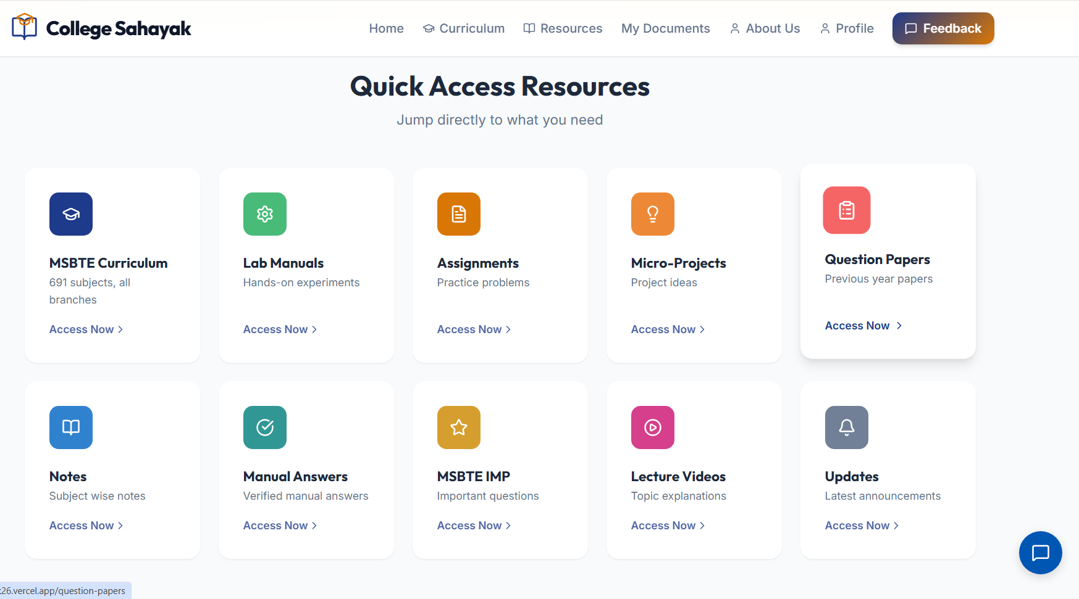
Fig 8.4 Quick Access Section (Home Page)
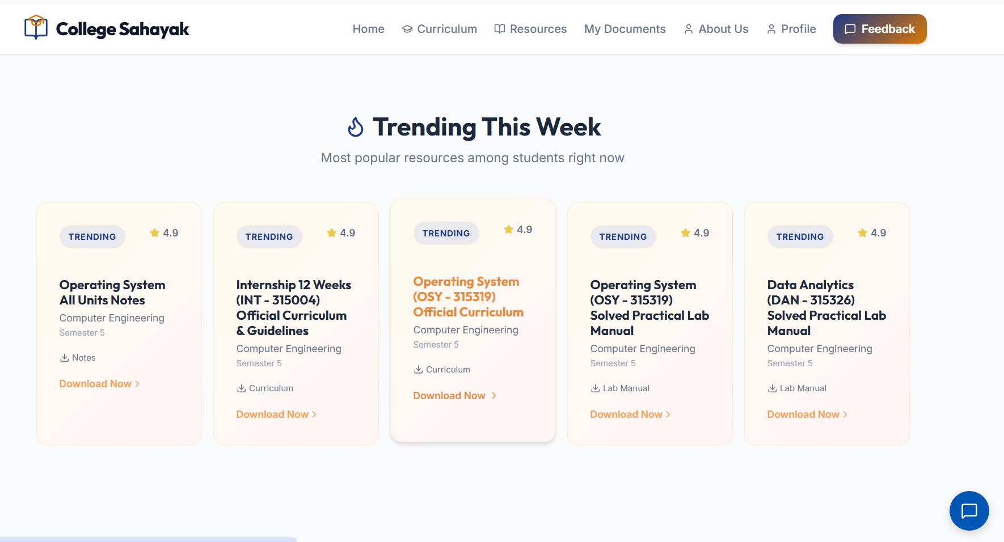
Fig 8.5 Trending this week Section (Home Page)

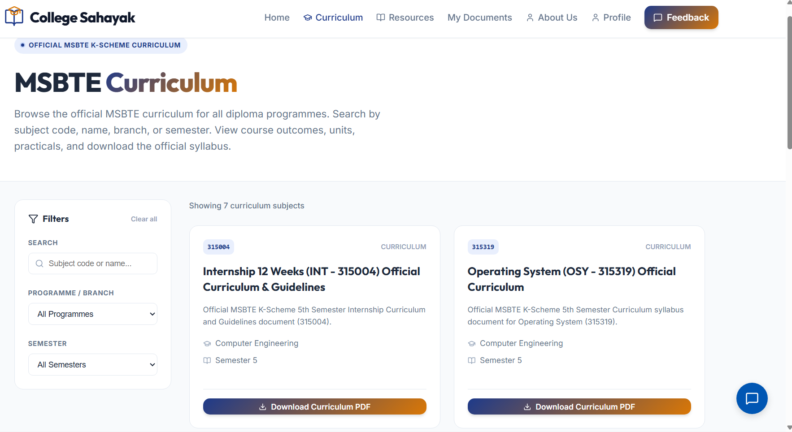
8.6 Curriculum Page (Other Resourses Pages)
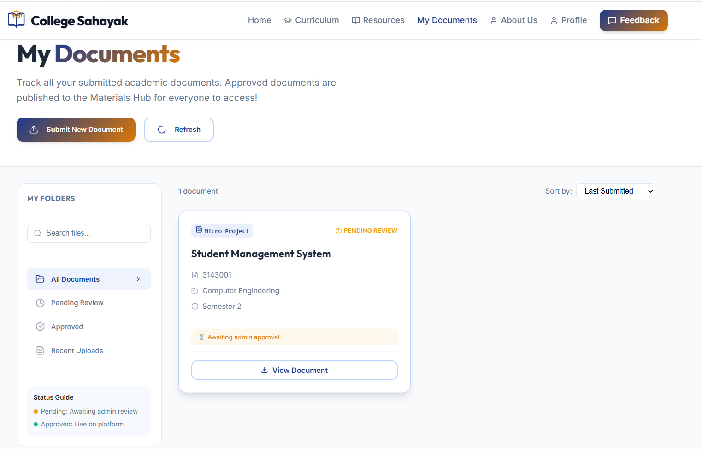
  - My Document Page
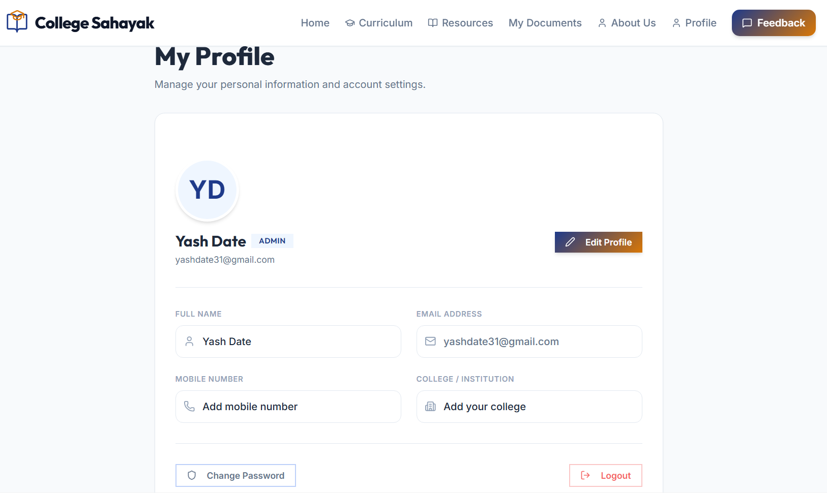
8.8 Profile Page
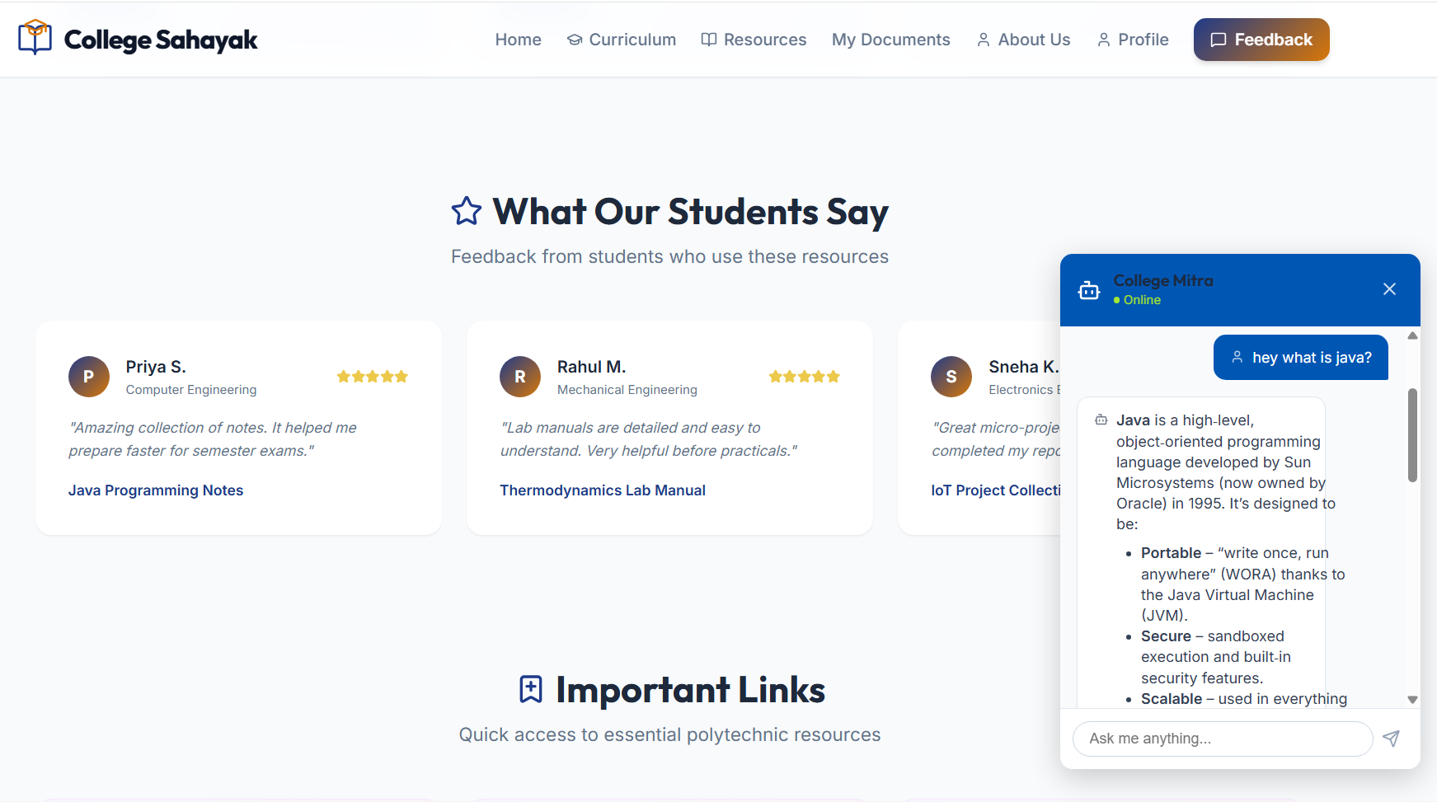
  - College Mitra (AI Assistant)

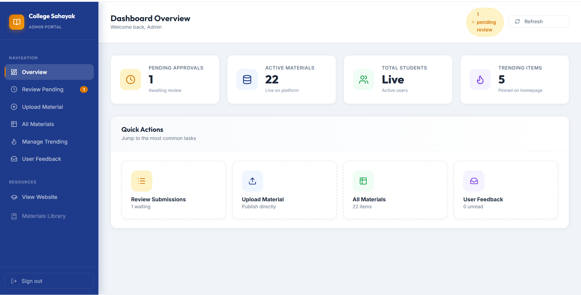
8.9 Admin Panel

CHAPTER 9
SPECIAL / CHALLENGING EXPERIENCES
THE CHALLENGES FACED DURING TRAINING INCLUDED:
- Understanding modern full-stack technologies quickly..
- Adapting to a professional IT and web development environment
- Improving communication and presentation skills.
- Developing REST APIs.
- Learning React.js.
- Managing structured databases using Supabase (PostgreSQL)..
- Integrating AI APIs.
- Completing assigned tasks within deadlines.
- To create projects within time
- Working on a live, real-time educational platform..

CHAPTER 10

CONCLUSION
My industrial training at Somayu Infotech was a truly valuable learning experience that helped me grow both technically and professionally. Throughout the training, I gained hands-on experience in Full-Stack Web Development, Node.js REST API Development, Artificial Intelligence Integration, Supabase (PostgreSQL), and Search Engine Optimization (SEO). Working on a real-world platform like College Sahayak allowed me to understand how software is actually designed, developed, and implemented in a professional environment.
Along with drastically improving my coding skills in React.js and backend logic, I also learned the importance of debugging complex network issues, testing, database management, problem-solving, teamwork, communication, and project management. The experience gave me a clear understanding of the complete software development lifecycle—from planning and development to cloud deployment and maintenance.
Overall, this training strengthened my confidence and equipped me with practical knowledge and industry-ready skills that will help me take on real-world challenges and build a successful career in the IT field.

CHAPTER 11
REFERENCES
OFFICIAL DOCUMENTATION
- https://www.somayuinfotech.com
- https://developer.mozilla.org
- https://react.dev
- https://nodejs.org
- https://expressjs.com
- https://python.org
- https://platform.openai.com/docs
- https://git-scm.com
- https://github.com/docs
- https://postman.com
- https://www.figma.com/

LEARNING RESOURCES
- YouTube Technical Channels

DEPLOYED PROJECTS
- Amazon (HTML & CSS) - https://amazon-e-shop.vercel.app/
- College Sahayak (React + Node) - https://internship-2k26.vercel.app/

DEPLOYMENT PLATFORMS

- Frontend: https://www.netlify.com/
- Backend: https://render.com/

